Pro-curo Licence Server
Admin Portal
Internal User Manual

Version 1.0
26 March 2026
Pro-curo Software Limited
INTERNAL USE ONLY — CONFIDENTIAL

Contents
Contents 2
1. Introduction 3
1.1 Who Should Use This Manual 3
1.2 System Requirements 3
1.3 Starting the Application 3
2. Logging In 4
2.1 Development Login 4
2.2 Signing Out 4
3. Navigating the Portal 5
4. Dashboard 6
4.1 Statistics Cards 6
4.2 Active Alerts 6
5. Customer Management 7
5.1 Creating a New Customer 7
5.2 Deployment Models 7
6. Licence Management 8
6.1 Understanding the Licence Table 8
6.2 Issuing a New Licence 8
6.3 Amending a Licence 9
6.4 Viewing Amendment History 10
6.5 Generating an Offline Licence File 10
6.6 Revoking a Licence 11
7. Instance Monitoring 12
7.1 Understanding the Instance Table 12
7.2 Check-In Status Indicators 12
8. Audit Log 13
8.1 Audit Log Table 13
8.2 Viewing Full Details 13
8.3 Action Types 13
9. Common Workflows 15
9.1 Onboarding a New Customer 15
9.2 Adding Users to an Existing Licence 15
9.3 Renewing an Expiring Licence 15
9.4 Investigating an Offline Instance 15
10. Glossary 16

1. Introduction
This manual provides step-by-step instructions for using the Pro-curo Licence Server Admin Portal. The Admin Portal is an internal tool used by Pro-curo Software Limited engineers to manage customer licences, monitor deployed instances, track invoices, and generate offline licence files.
The portal is a web-based application accessible via a browser. During development it runs locally in Docker; in production it will be available at a dedicated URL secured by Azure AD single sign-on (SSO).

1.1 Who Should Use This Manual
This manual is intended for Pro-curo Software engineers and administrators responsible for issuing, amending, and monitoring Pro-curo V5 licences.

1.2 System Requirements
- A modern web browser (Chrome, Edge, or Firefox recommended)
- Docker Desktop (for local development)
- Network access to the licence server (port 3100 for API, port 5174 for portal)

1.3 Starting the Application
To start the licence server and admin portal locally, run the following command from the project root directory:
docker-compose up --build
Once all three containers are running (database, API server, admin portal), open your browser and navigate to:
http://localhost:5174

2. Logging In
When you first open the Admin Portal, you will be presented with the login screen.

2.1 Development Login
During development, the portal uses a simplified email-only login. No password is required.
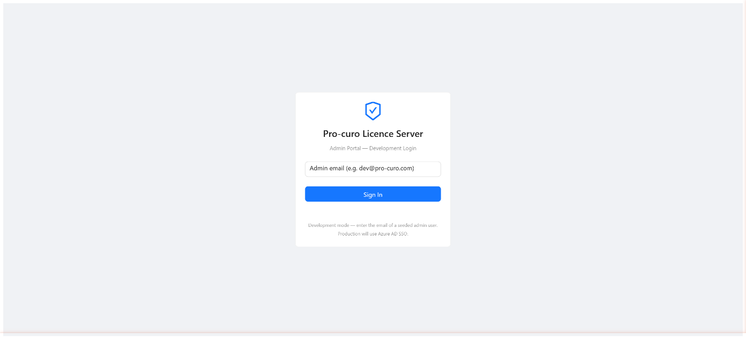Figure 1: The Login Screen
Step 1: Enter your admin email address
Type the email address of a seeded admin user into the email field. The default development admin account is dev@pro-curo.com.
Step 2: Click Sign In
Press the Sign In button. If the email matches a registered admin user, you will be redirected to the Dashboard.
Note: In production, this login screen will be replaced by Azure AD single sign-on (SSO). You will sign in using your Pro-curo Microsoft account.

2.2 Signing Out
To sign out, click your name in the top-right corner of the header bar, then select Sign Out from the dropdown menu. You will be returned to the login screen.

3. Navigating the Portal
The Admin Portal uses a sidebar navigation on the left-hand side. The sidebar contains links to the five main areas of the portal:
Page | Icon | Purpose
Dashboard | Dashboard icon | Overview statistics and active alerts
Customers | Team icon | Manage customer organisations
Licences | Certificate icon | Issue, amend, and manage licences
Instances | Server icon | Monitor deployed Pro-curo V5 instances
Audit Log | Audit icon | View a full log of all admin actions

The sidebar can be collapsed by clicking the toggle at the bottom. When collapsed, only icons are shown. The current server build number is displayed at the very bottom of the sidebar in small monospaced text.
Your name and role are shown in the top-right header. Clicking your name opens a dropdown with the option to sign out.

4. Dashboard
The Dashboard is the home page of the Admin Portal. It provides a high-level overview of the licence server status.
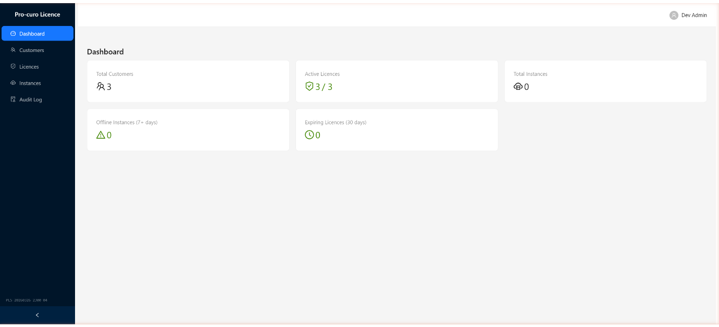Figure 2: The Dashboard showing statistics cards and alerts

4.1 Statistics Cards
The top of the Dashboard displays five statistics cards:
Card | Description
Total Customers | The total number of customer organisations registered in the system.
Active Licences | The number of currently active licences, shown alongside the total number of all licences (e.g. 8 / 12).
Total Instances | The total number of Pro-curo V5 instances that have registered with the licence server.
Offline Instances (7+ days) | The number of instances that have not checked in for more than seven days. Displayed in red if any are offline.
Expiring Licences (30 days) | The number of licences expiring within the next 30 days. Displayed in amber if any are expiring.

4.2 Active Alerts
Below the statistics cards, the Dashboard shows two alert tables if there are any issues requiring attention:
- Offline Instances: Lists instances that have not checked in recently, showing the customer name, instance UUID, last check-in date, and severity (warning or critical).
- Expiring Licences: Lists licences approaching their expiry date, showing the customer name, expiry date, and severity.
Tip: Check the Dashboard regularly to identify customers who may need licence renewals or whose instances have gone offline unexpectedly.

5. Customer Management
The Customers page lists all customer organisations registered in the licence server. Each row shows the organisation name, contact email, deployment model, number of licences, and creation date.
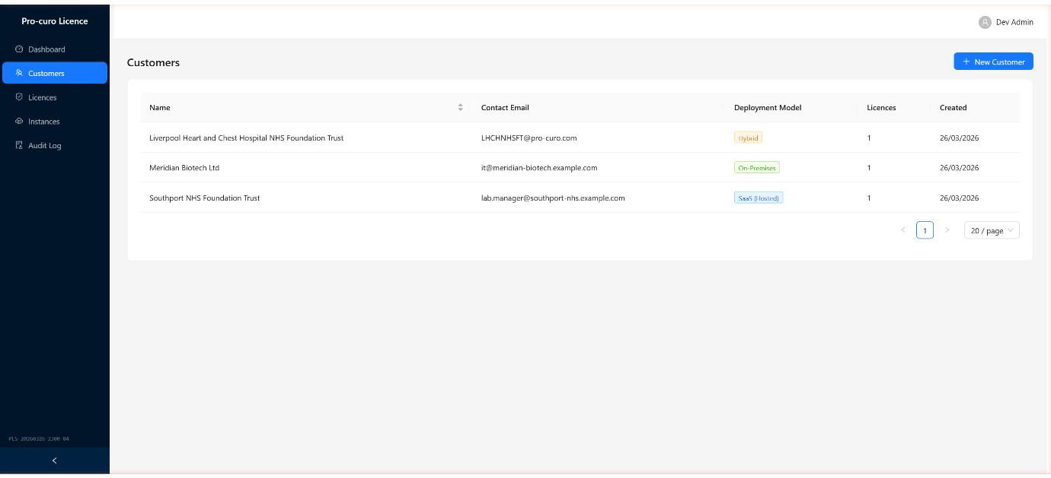Figure 3: The Customers page listing all registered organisations

5.1 Creating a New Customer
Before issuing a licence, the customer organisation must be created.
Step 1: Click New Customer
Click the blue New Customer button in the top-right corner of the Customers page.
Step 2: Fill in the form
Complete the required fields in the modal that appears:
Field | Required | Description
Organisation Name | Yes | The full name of the customer organisation (e.g. Southport NHS Foundation Trust).
Contact Email | Yes | The primary contact email address for the customer.
Deployment Model | Yes | Select the deployment type: Model A (SaaS/Hosted), Model B (Hybrid), or Model C (On-Premises).
Notes | No | Any additional notes about the customer.

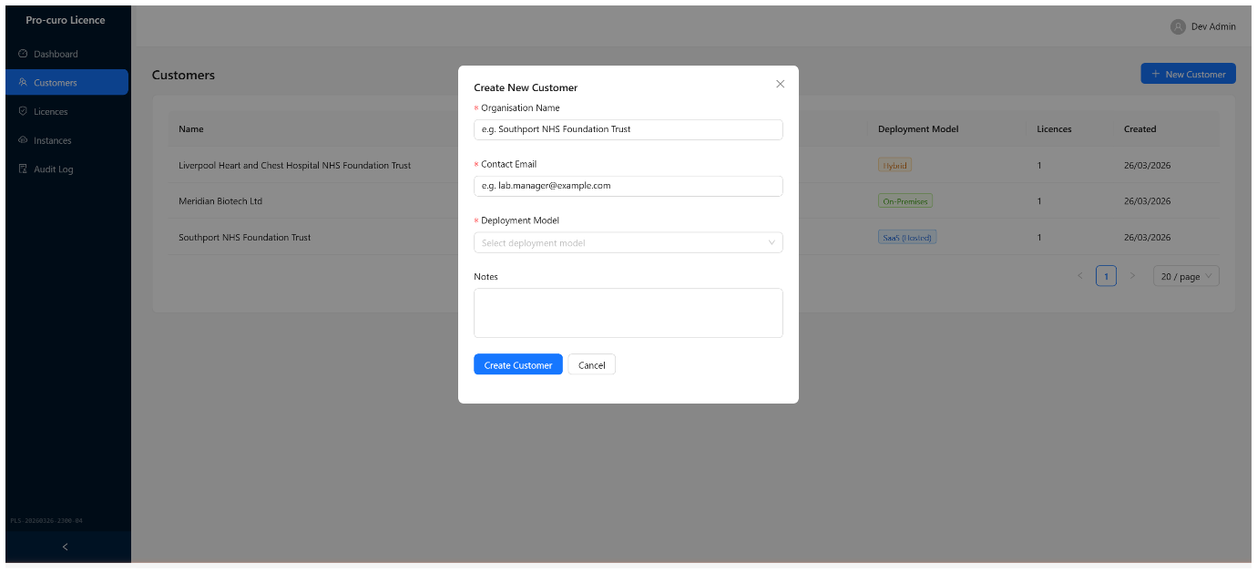Figure 4: The Create New Customer form
Step 3: Click Create Customer
Click the Create Customer button to save. The customer will appear in the table immediately.

5.2 Deployment Models
Pro-curo V5 supports three deployment models, which affect how licences and instances behave:
- Model A — SaaS (Hosted): Pro-curo hosts the application. The customer accesses it via the internet. Check-ins happen automatically.
- Model B — Hybrid: The customer hosts the application on their own infrastructure but it connects to the internet for check-ins.
- Model C — On-Premises: Fully air-gapped. No internet connectivity. Requires offline licence files.

6. Licence Management
The Licences page is the primary working area of the Admin Portal. From here you can issue new licences, amend existing ones, generate offline licence files, and revoke licences.
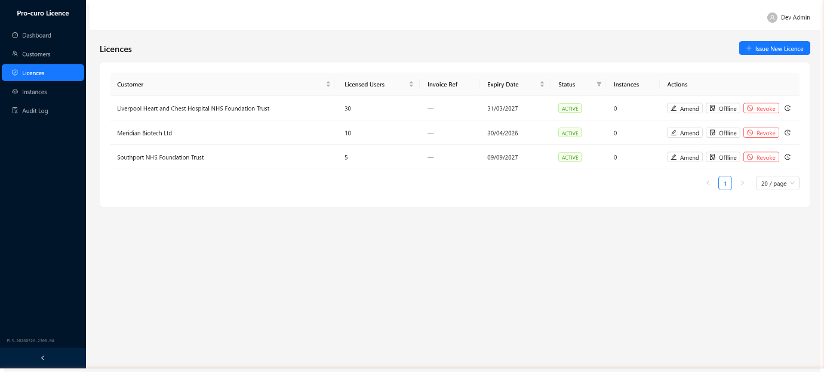Figure 5: The Licences page with action buttons

6.1 Understanding the Licence Table
The licence table displays one row per licence with the following columns:
Column | Description
Customer | The customer organisation the licence belongs to.
Licensed Users | The maximum number of concurrent users permitted under this licence.
Invoice Ref | The FreeAgent invoice reference associated with the licence, if one has been set.
Expiry Date | The date the licence expires. Shown in red if already expired.
Status | The current status: ACTIVE (green), SUSPENDED (amber), EXPIRED (red), or REVOKED (dark red).
Instances | The number of Pro-curo V5 instances registered against this licence.
Actions | Buttons to amend, generate offline files, view history, or revoke the licence.

The table supports sorting by clicking column headers, and the Status column can be filtered using the filter icon.

6.2 Issuing a New Licence
To issue a new licence to a customer:
Step 1: Click Issue New Licence
Click the blue Issue New Licence button at the top of the page.
Step 2: Complete the form
Fill in the required fields:
Field | Required | Description
Customer | Yes | Select the customer from the dropdown. You can type to search.
Licensed Users | Yes | The number of concurrent users. Type a number or use the up/down arrows.
Expiry Date | Yes | The date the licence will expire. Must be in the future.
Invoice Reference | No | The FreeAgent invoice number for this licence (e.g. INV-001234).
Notes | No | Any additional notes.

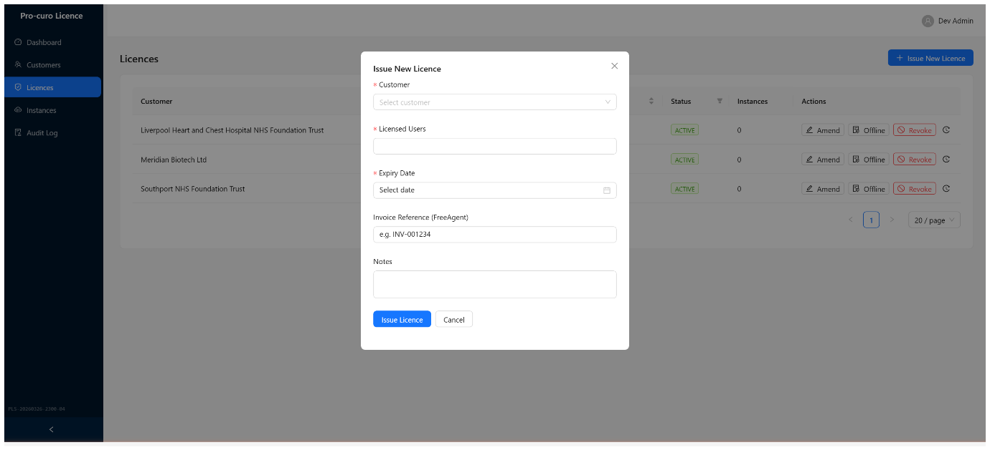Figure 6: The Issue New Licence form with Invoice Reference field
Step 3: Click Issue Licence
Click the Issue Licence button. The system will generate a unique licence key.
Step 4: Copy the licence key
A modal will display the generated licence key in the format PCV5-XXXX-XXXX-XXXX-XXXX. Copy this key immediately and provide it to the customer.
Note: The licence key is shown only once. It is stored as a hashed value in the database and cannot be retrieved later. If lost, you must revoke the licence and issue a new one.

6.3 Amending a Licence
Amendments allow you to modify an existing licence — for example, when a customer purchases additional users, renews their contract, or extends their expiry date. Each amendment is tracked with its own FreeAgent invoice reference.
Step 1: Click Amend
On the licence row, click the Amend button (pencil icon). This is only available for active licences.
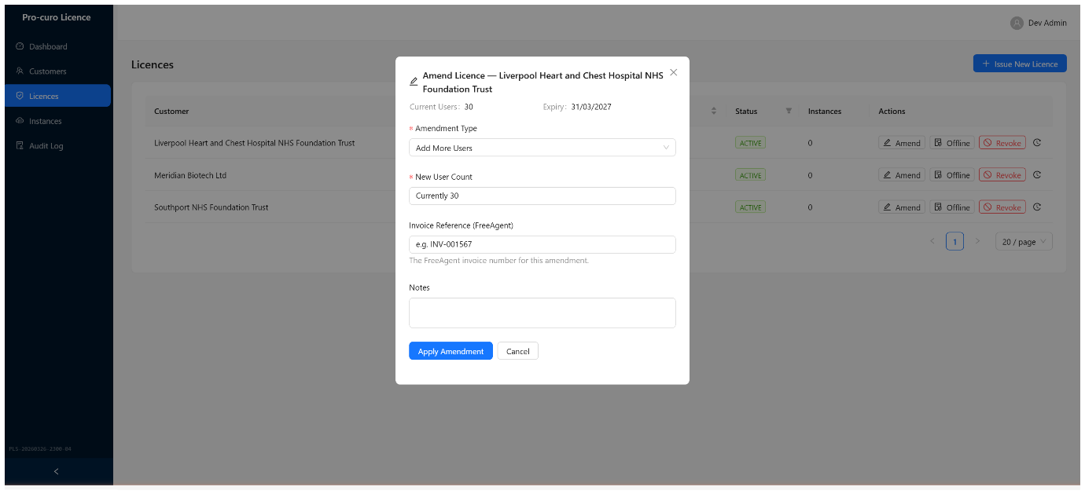Figure 7: The Amend Licence modal showing amendment type, user count, and invoice reference
Step 2: Select the amendment type
Choose one of the four amendment types from the dropdown:
Type | What It Does | Required Fields
Add More Users | Increases the licensed user count. | New User Count (must be higher than current).
Reduce Users | Decreases the licensed user count. | New User Count (must be lower than current).
Renewal | Renews the licence with a new expiry date. | New Expiry Date. New User Count is optional.
Extend Expiry | Extends the expiry date only. | New Expiry Date.

Step 3: Enter the FreeAgent invoice reference
Enter the invoice number for this amendment (e.g. INV-001567). This creates an audit trail linking each commercial change to a specific invoice.
Step 4: Add optional notes
Enter any notes to describe the reason for the amendment.
Step 5: Click Apply Amendment
Click Apply Amendment to save. The licence will be updated immediately.
Step 6: Generate a new offline file (if applicable)
After a successful amendment, the system will prompt you to generate a new offline licence file. If the customer uses an offline (air-gapped) deployment, click Generate Offline File. If the customer uses online check-in only, click Skip.
Note: Always generate a new offline file after amending a licence for an on-premises customer. The previous file contains the old entitlement data (e.g. the old user count) and will not reflect the amendment.

6.4 Viewing Amendment History
To view the full history of amendments for a licence:
Step 1: Click the history icon
On the licence row, click the clock icon button at the far right of the Actions column.
Step 2: Review the timeline
A modal displays the amendment history as a colour-coded timeline. Each entry shows the amendment type, date and time, previous and new user counts, invoice reference, and any notes.
From the amendment history modal you can also click View Offline File History to see all offline licence files that have been generated for this licence.

6.5 Generating an Offline Licence File
Offline licence files are cryptographically signed files that allow Pro-curo V5 to validate its licence without connecting to the licence server. These are essential for on-premises (Model C) deployments.
Step 1: Click Offline
On the licence row, click the Offline button (shield icon). This is only available for active licences.
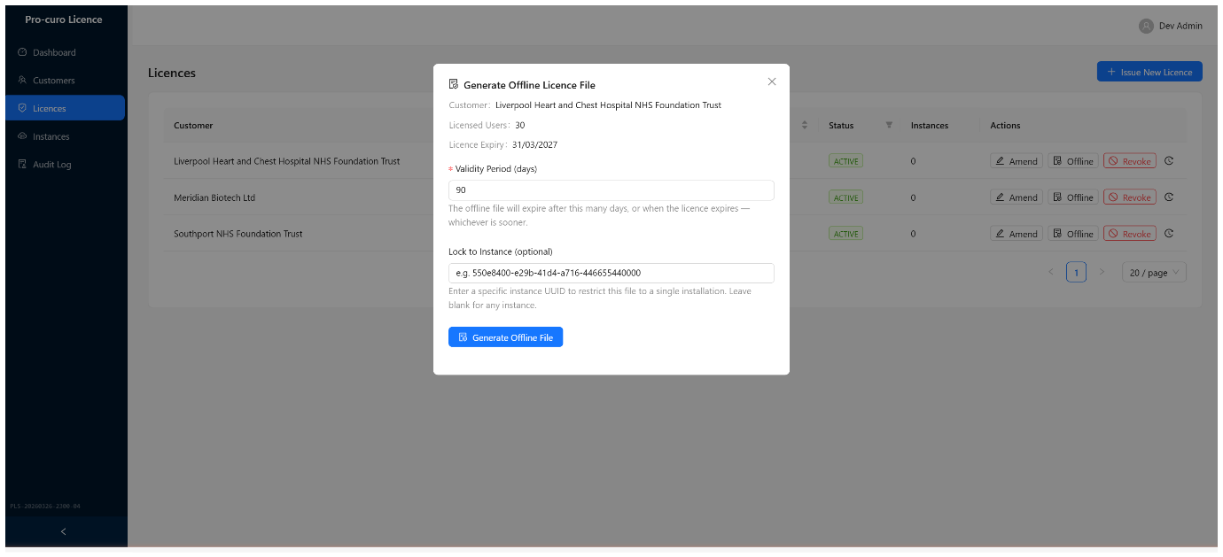Figure 8: The Generate Offline Licence File modal
Step 2: Set the validity period
Enter the number of days the offline file should be valid. The default is 90 days. The effective expiry will be the earlier of the validity period or the licence expiry date.
Step 3: Optionally lock to an instance
If you want to restrict the offline file to a specific Pro-curo V5 installation, enter the instance UUID. Leave blank to allow any instance to use the file.
Step 4: Click Generate Offline File
Click the Generate Offline File button. The server will create and sign the file using Ed25519 cryptography.
Step 5: Download the .lic file
Once generated, the modal shows the file details including the customer name, expiry date, and SHA-256 hash. Click the Download .lic File button to save it. The file is named in the format procuro-offline-[customer]-[date].lic.
Step 6: Provide the file to the customer
Send the downloaded .lic file to the customer for installation on their air-gapped system. The file is tamper-proof — any modification will invalidate the Ed25519 signature.

6.6 Revoking a Licence
Revoking a licence permanently deactivates it. The customer’s Pro-curo V5 instance will enter read-only mode after the 30-day grace period expires.
Step 1: Click Revoke
On the licence row, click the red Revoke button. A confirmation dialog will appear.
Step 2: Confirm revocation
Click Revoke in the confirmation dialog to proceed. This action cannot be undone.
Note: Revocation is permanent. If a customer’s licence was revoked in error, you will need to issue a completely new licence and provide the customer with the new key.

7. Instance Monitoring
The Instances page shows all Pro-curo V5 installations that have registered with the licence server via the check-in process. This page is read-only — data is populated automatically when instances check in.
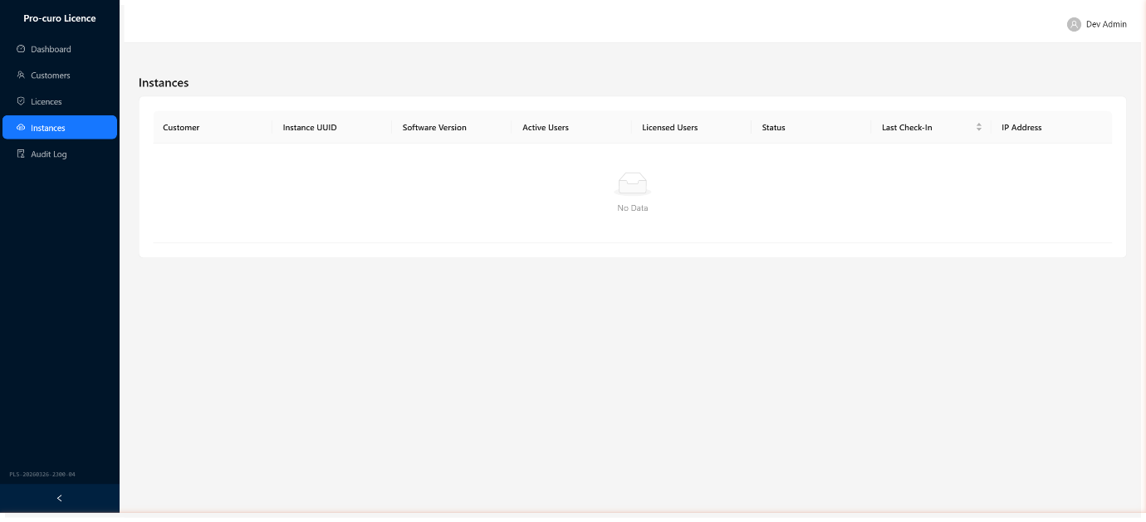Figure 9: The Instances page showing all deployed installations

7.1 Understanding the Instance Table
Column | Description
Customer | The customer organisation this instance belongs to (via the licence).
Instance UUID | A unique identifier for the installation. Shown truncated; click the copy icon to copy the full UUID.
Software Version | The Pro-curo V5 build number running on this instance.
Active Users | The number of users currently active on this instance (as reported at last check-in).
Licensed Users | The maximum users allowed by the associated licence.
Status | A colour-coded tag showing the check-in status (see below).
Last Check-In | The date and time of the most recent check-in.
IP Address | The IP address from which the instance last checked in.

7.2 Check-In Status Indicators
Status | Colour | Meaning
Online | Green | Checked in within the last 24 hours.
Recent | Blue | Checked in within the last 7 days.
Offline (Xd) | Amber | Has not checked in for 7–30 days. The number of days is shown.
Offline (Xd) | Red | Has not checked in for more than 30 days (critical).
Never | Grey | The instance has registered but never completed a check-in.

Tip: If an instance shows as offline for an extended period, contact the customer to verify their system is running correctly and can reach the licence server.

8. Audit Log
The Audit Log records every action performed through the Admin Portal. It provides a complete, tamper-evident trail of all administrative operations for compliance and troubleshooting purposes.
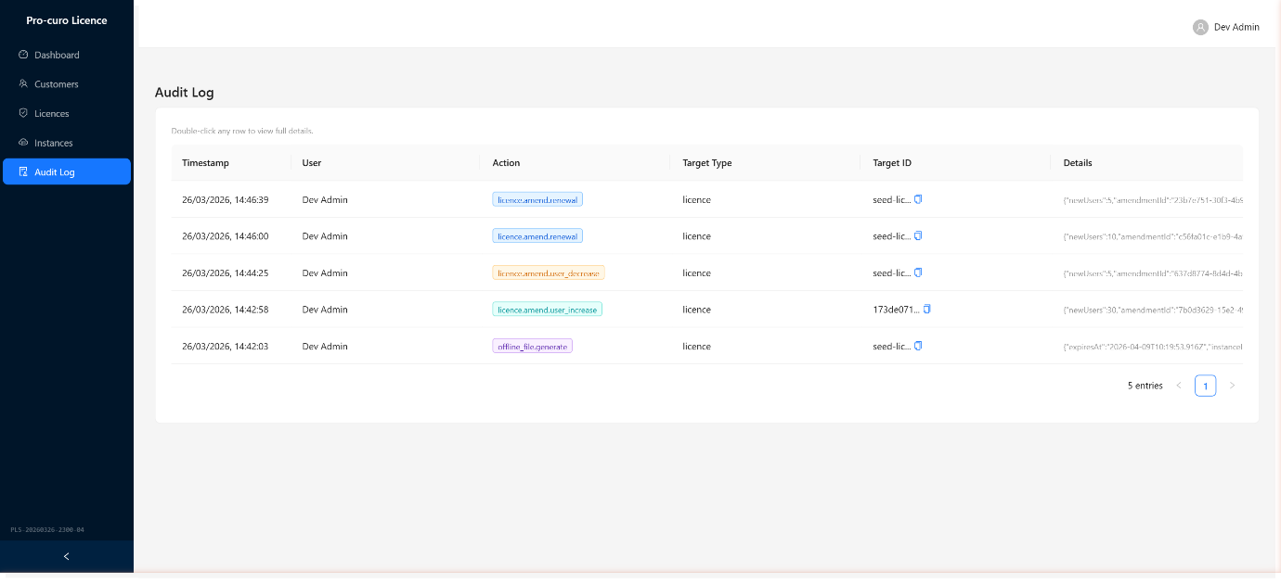Figure 10: The Audit Log showing colour-coded action entries

8.1 Audit Log Table
The table shows a paginated list of audit entries (50 per page) with the following columns:
Column | Description
Timestamp | The date and time the action was performed, formatted in UK date style (DD/MM/YYYY HH:MM:SS).
User | The admin user who performed the action.
Action | A colour-coded tag describing the action type.
Target Type | The type of entity affected (e.g. licence, customer, offline_file).
Target ID | The database ID of the affected entity (shown truncated, with a copy button).
Details | A preview of additional data associated with the event.

8.2 Viewing Full Details
The Details column in the table view is often too narrow to display the full event data. To view the complete details:
Step 1: Double-click any row
Double-click on the audit log entry you want to inspect. A detail modal will open.
Step 2: Review the full entry
The modal shows all fields including the full Target ID (copyable), the Entry ID, and the complete details payload formatted as JSON.
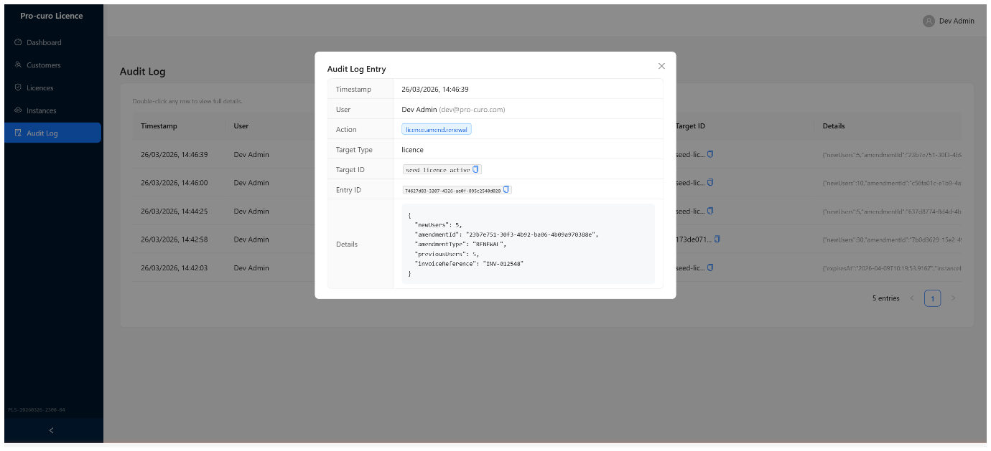Figure 11: The Audit Log detail modal with formatted JSON
Tip: A hint is displayed above the table reminding you that double-click opens the detail view.

8.3 Action Types
The following action types are recorded in the audit log:
Action | Colour | Description
licence.create | Green | A new licence was issued.
licence.update | Blue | A licence was modified.
licence.revoke | Red | A licence was revoked.
licence.amend.user_increase | Cyan | A licence was amended to add more users.
licence.amend.user_decrease | Orange | A licence was amended to reduce users.
licence.amend.renewal | Blue | A licence was renewed.
licence.amend.expiry_extension | Geekblue | A licence expiry was extended.
offline_file.generate | Purple | An offline licence file was generated.
customer.create | Green | A new customer was created.
customer.update | Blue | A customer record was updated.

9. Common Workflows

9.1 Onboarding a New Customer
- Go to Customers and click New Customer. Enter the organisation name, contact email, and deployment model.
- Go to Licences and click Issue New Licence. Select the new customer, enter the user count and expiry date, and add the FreeAgent invoice reference.
- Copy the generated licence key and securely provide it to the customer.
- If the customer is on-premises (Model C), generate an offline licence file and send it to them.

9.2 Adding Users to an Existing Licence
- Go to Licences and find the customer’s licence.
- Click Amend and select Add More Users.
- Enter the new total user count and the FreeAgent invoice reference for this purchase.
- Click Apply Amendment.
- If the customer is on-premises, accept the prompt to generate a new offline file.

9.3 Renewing an Expiring Licence
- Check the Dashboard for licences expiring within 30 days.
- Go to Licences, find the licence, and click Amend.
- Select Renewal, enter the new expiry date, and optionally update the user count.
- Enter the FreeAgent invoice reference for the renewal and click Apply Amendment.

9.4 Investigating an Offline Instance
- Check the Dashboard for offline instance alerts.
- Go to Instances and find the instance by customer name or UUID.
- Note the Last Check-In date, software version, and IP address.
- Contact the customer to investigate. Common causes include network changes, firewall rules, or the Pro-curo service being stopped.

10. Glossary
Term | Definition
Check-in | A daily automated process where a Pro-curo V5 instance contacts the licence server to validate its licence and report status.
Grace period | A 30-day window after licence expiry or revocation during which the system continues to operate in full mode before reverting to read-only.
Licence key | A unique key in the format PCV5-XXXX-XXXX-XXXX-XXXX that identifies a specific licence entitlement. Stored as a bcrypt hash.
Offline licence file | A cryptographically signed .lic file containing licence entitlements for air-gapped deployments. Signed using Ed25519.
Instance | A single deployed installation of Pro-curo V5, identified by a unique UUID.
Amendment | A modification to an existing licence (e.g. adding users, renewing, extending expiry), each tracked with its own invoice reference.
FreeAgent | The accounting software used by Pro-curo Software Limited. Invoice references from FreeAgent are recorded against licences and amendments.
Ed25519 | A modern elliptic-curve digital signature algorithm used to sign offline licence files and check-in responses. Ensures tamper-proofing.
HMAC-SHA256 | A keyed-hash message authentication code used to validate check-in request payloads. Ensures requests originate from legitimate instances.
Build ID | A version identifier displayed in the sidebar, formatted as PLS-YYYYMMDD-HHMM-NN for the licence server.

End of Document
Pro-curo Software Limited — Registered in England and Wales (Company No. 07510777)

